Interaction supplement

Main effect of A
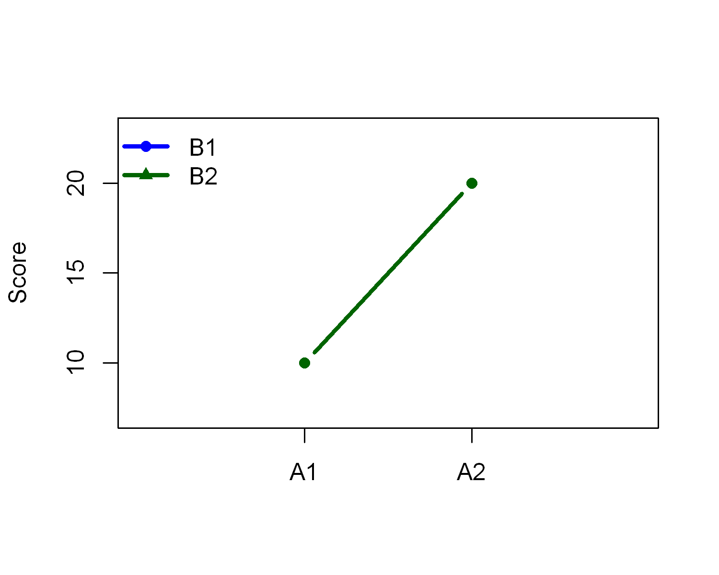
 | B1 | B2
A1 | 10 | 10
A2 | 20 | 20

Main effect of B
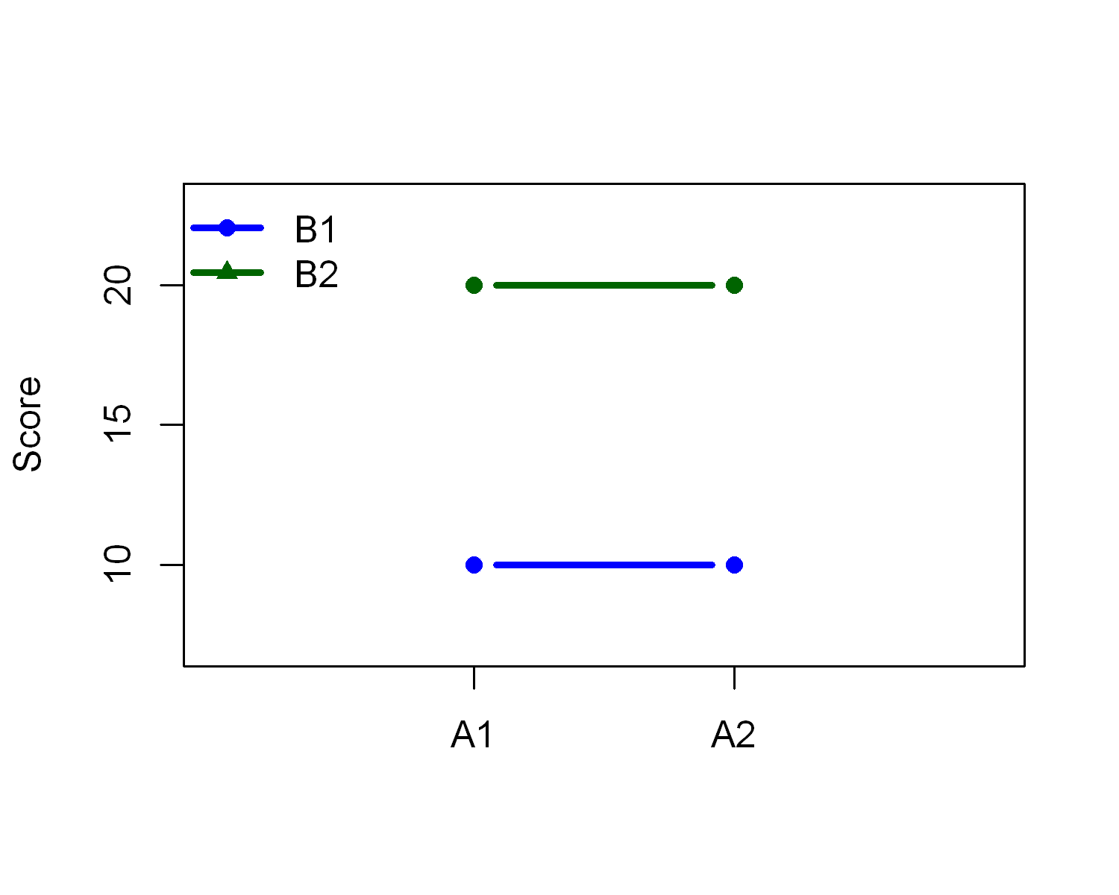
 | B1 | B2
A1 | 10 | 20
A2 | 10 | 20

Main effect of A & B (no interaction)
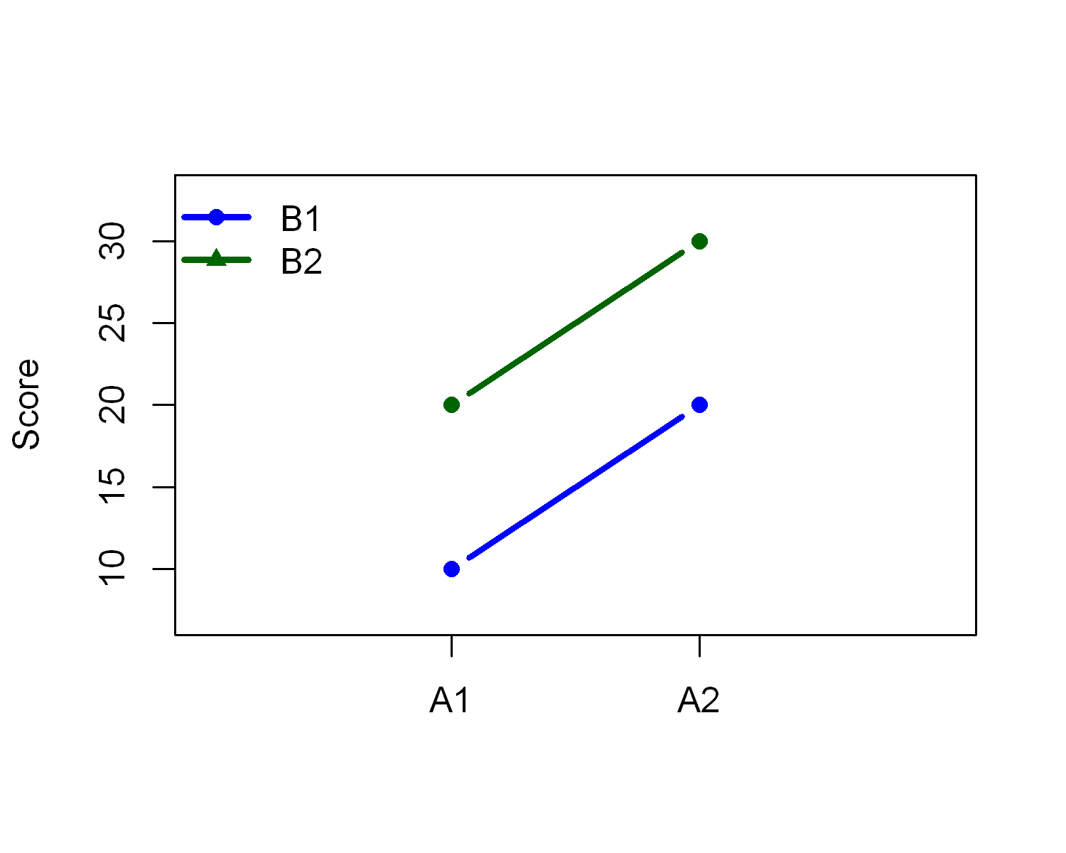
 | B1 | B2
A1 | 10 | 20
A2 | 20 | 30

No effect
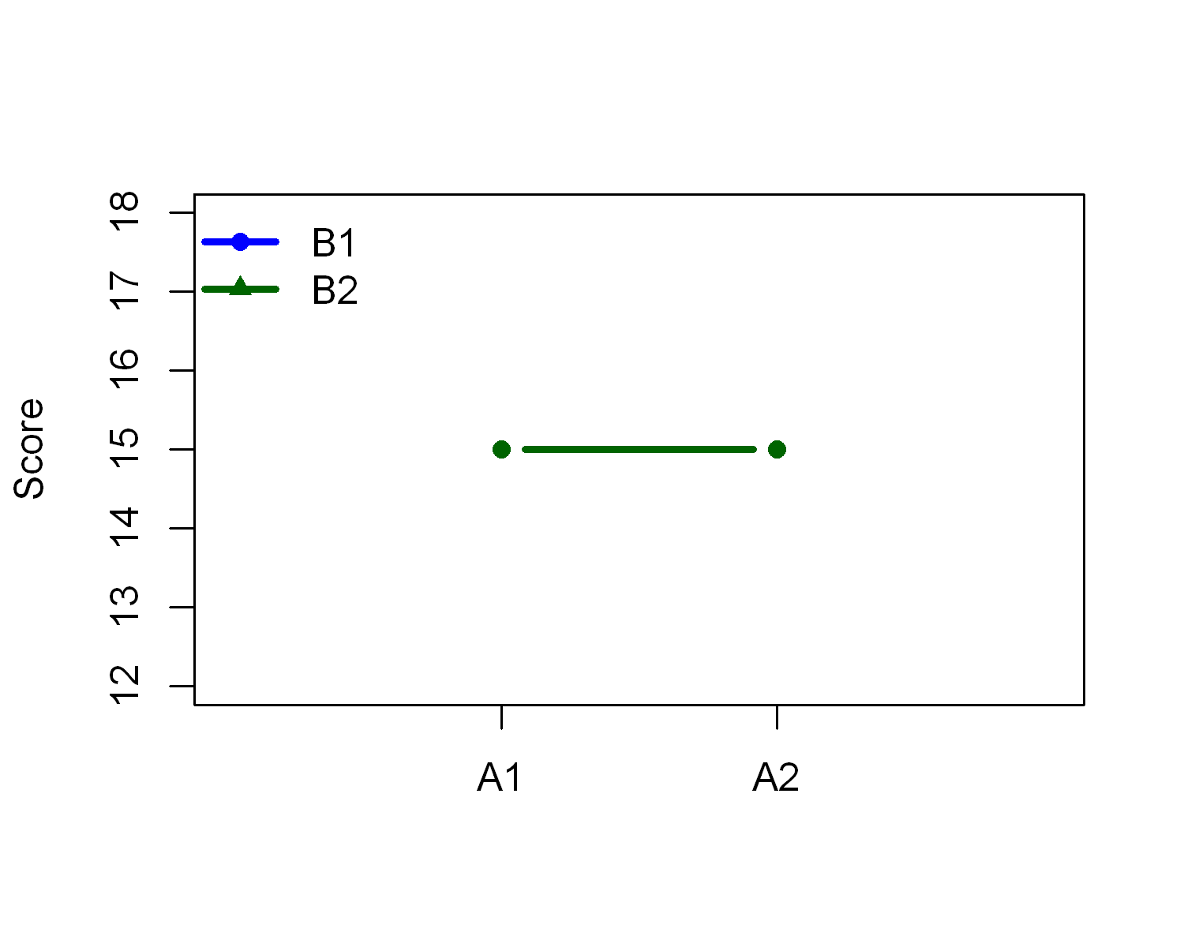
 | B1 | B2
A1 | 15 | 15
A2 | 15 | 15

One-way interaction with no main effect
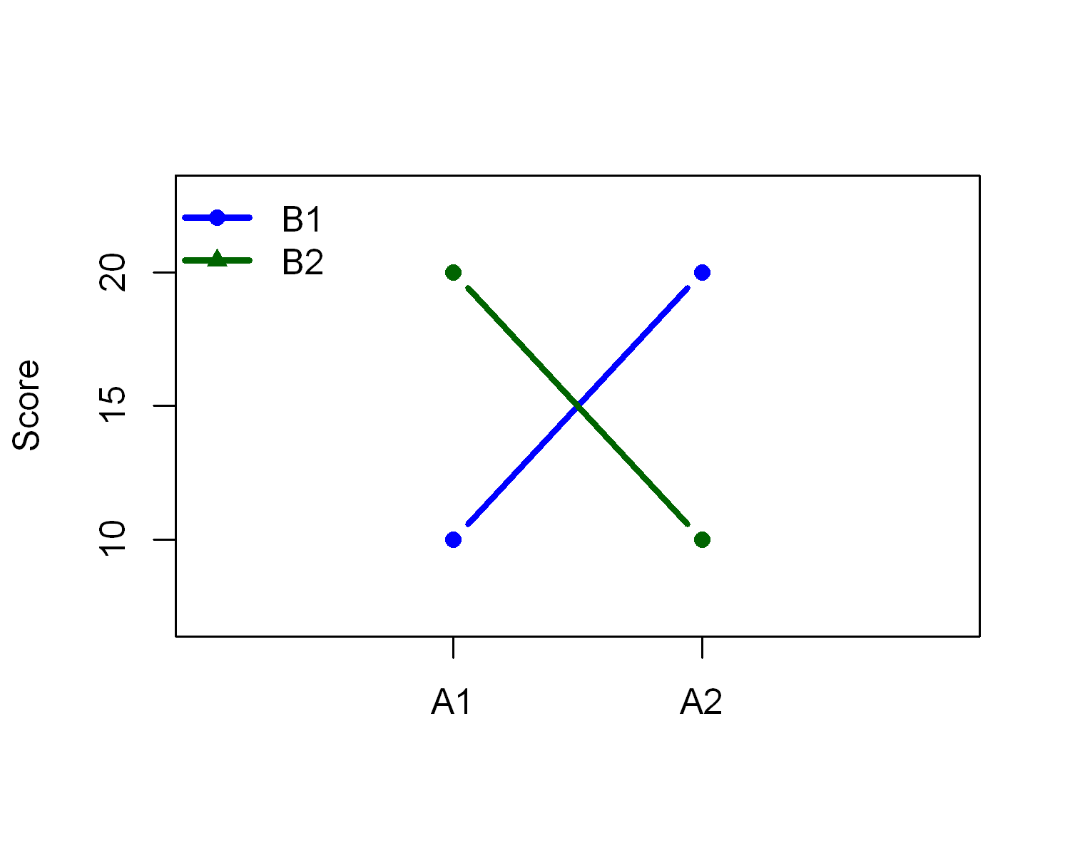
 | B1 | B2
A1 | 10 | 20
A2 | 20 | 10

One-way interaction with main effects of both A & B
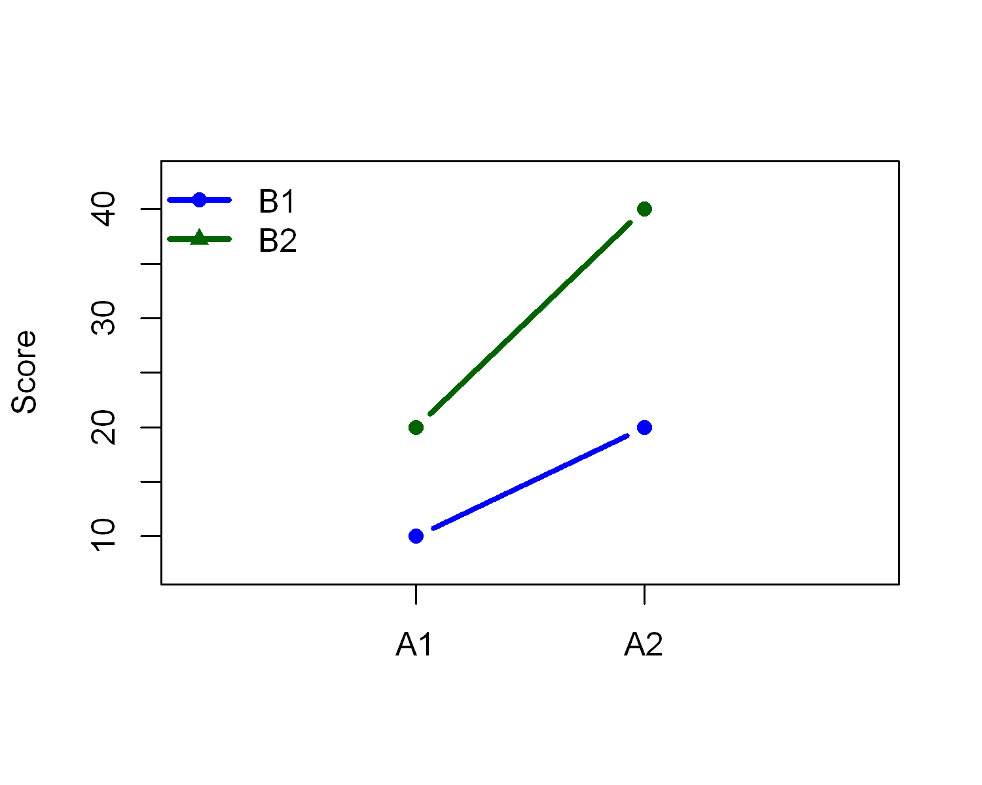
 | B1 | B2
A1 | 10 | 20
A2 | 20 | 40

Another one-way interaction with main effects of both A & B
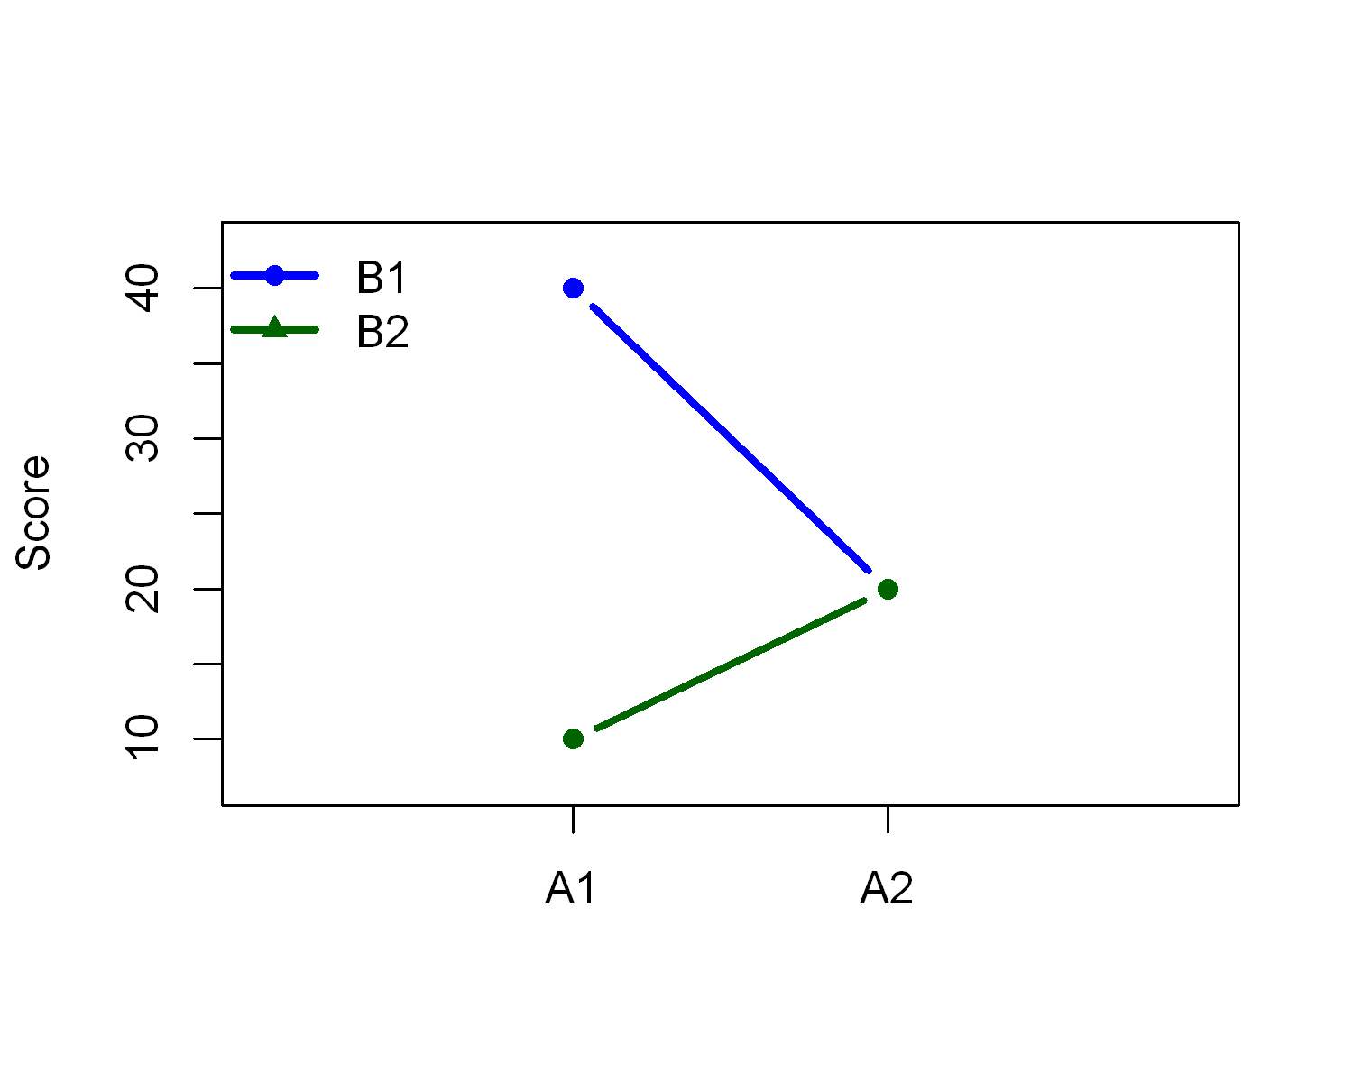
 | B1 | B2
A1 | 40 | 10
A2 | 20 | 20

Make your own Two-way

 | B1 | B2
A1 | 40 | 10
A2 | 20 | 20

Three way interaction.
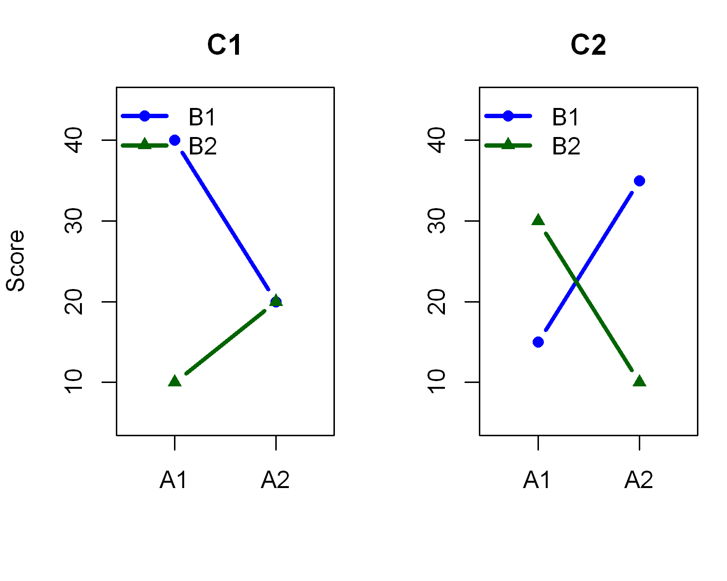

Two way interaction with three variables, no main effect of C
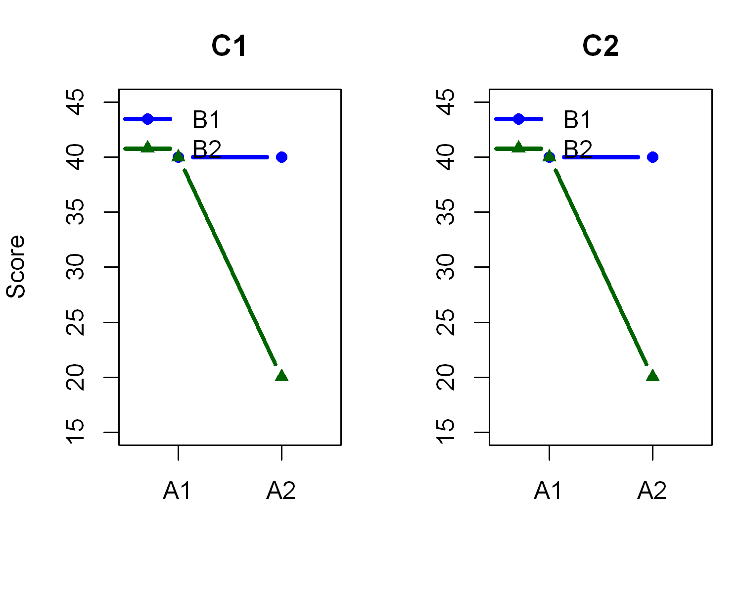

Two way interaction with three variables, with a main effect of C
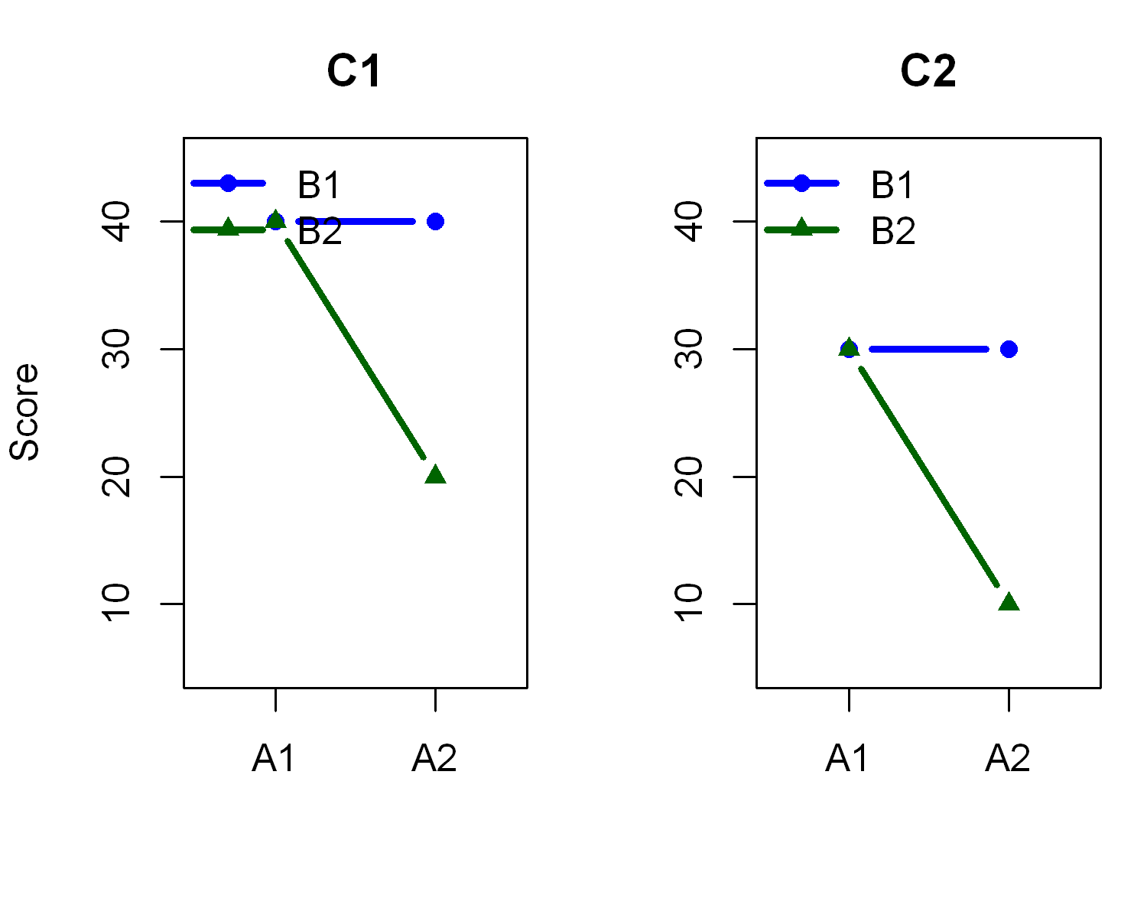

Make your own.
